

Automated Registration Process

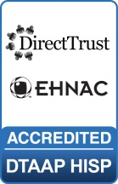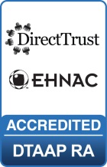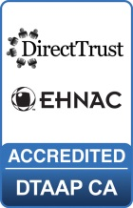

.

MaxMD

2200 Fletcher Ave, Suite 506

Fort Lee, New Jersey 07024

201.963.0005

www.DirectmdEmail.com

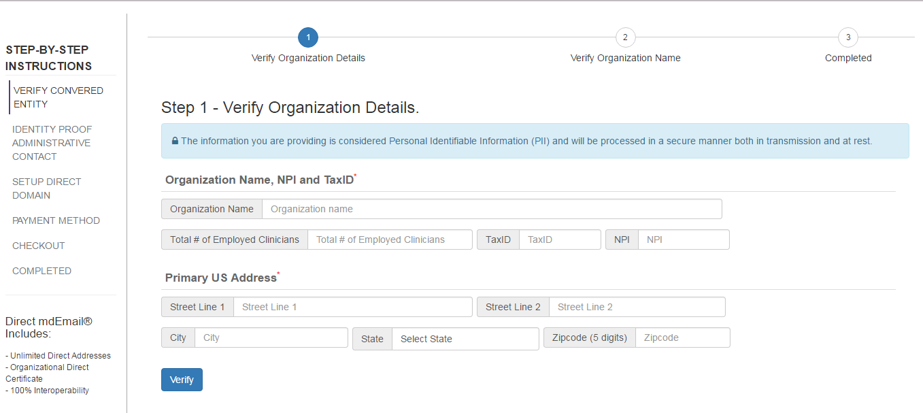

*An administrator should begin the automated process by verifying the details of their organization. This administrator will have the ability to request Direct Addresses at the end of the process.*

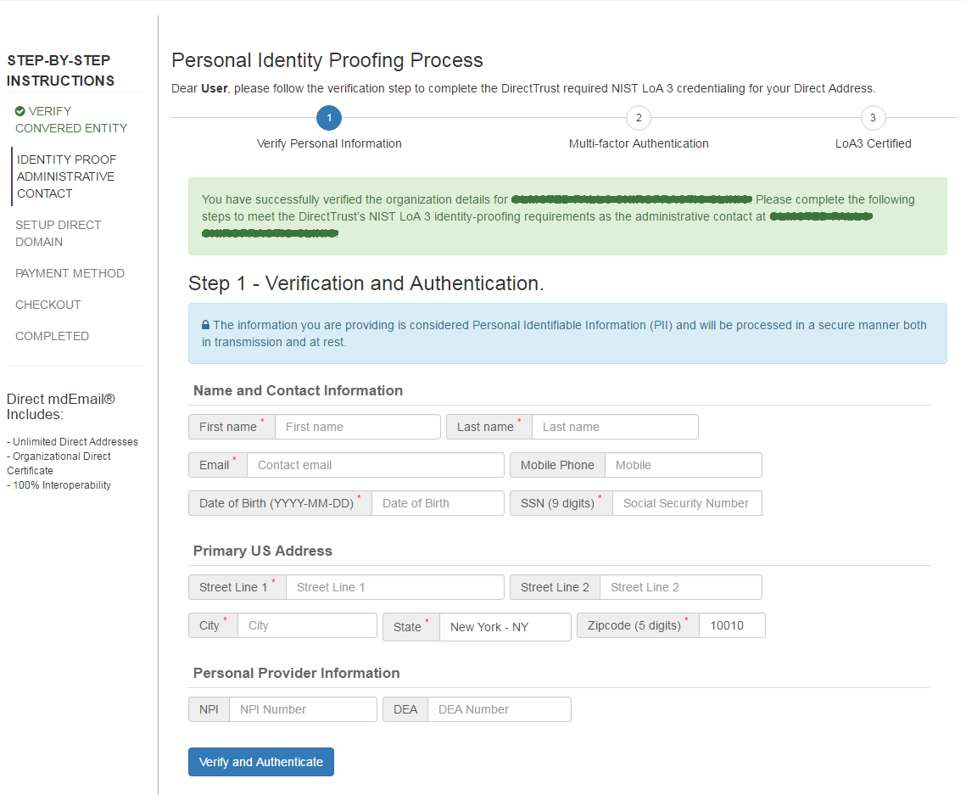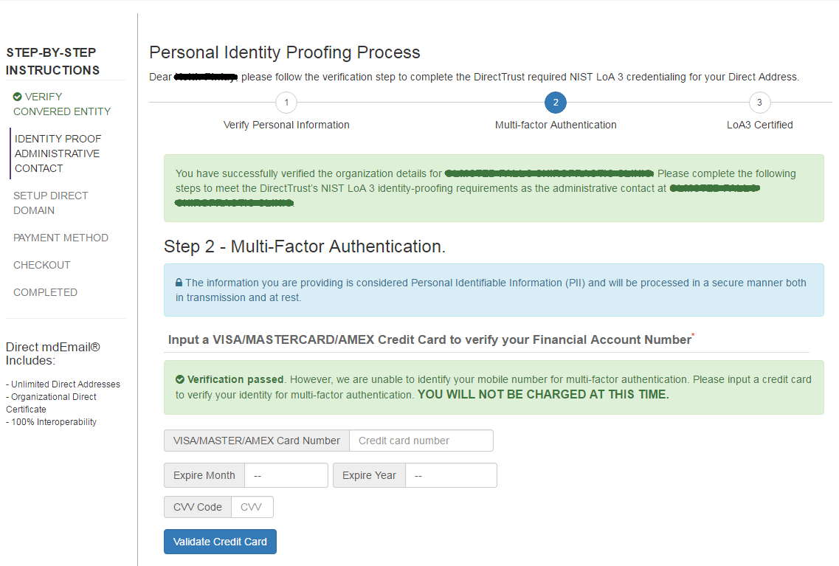

*Completing this identity proofing page will get the administrator to NIST LoA 2. The DirectTrust requires NIST LoA 3 identity proofing.*

*To get to the required NIST LoA 3 standard, the administrator will go through multi-factor authentication by either entering a one-time password sent to a cell phone or by entering a credit card number. THE CREDIT CARD WILL NOT BE CHARGED.*

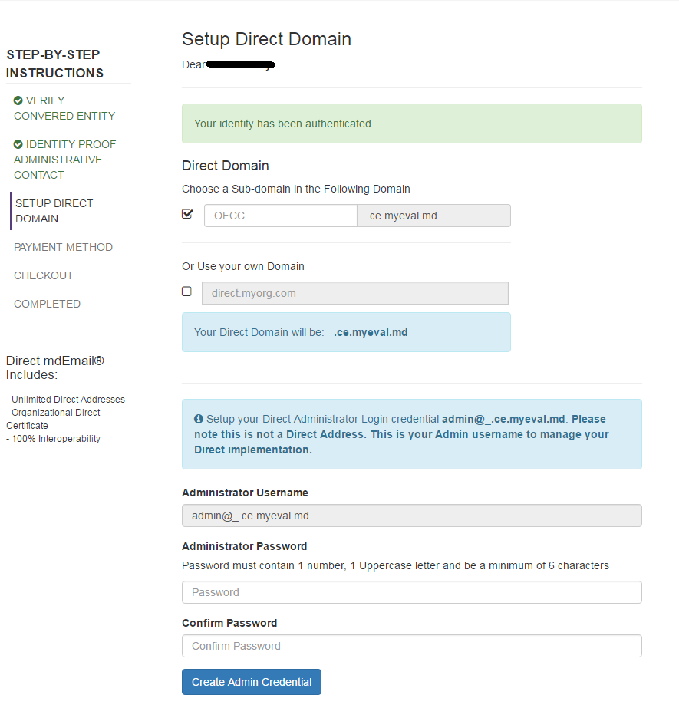

*The Direct Admin is not a Direct Address. It is a login mechanism for an administrator to access an interface to provision new Direct Addresses, run activity reports, and view their Direct Certificate.*

*The organization has the option to use their own domain or a custom sub-domain of @___.directmessaging.net (this screenshot showing myeval.md is from our testing site). If they elect to use their own domain we will provide printable instructions to configure direct.exampledomain.com*

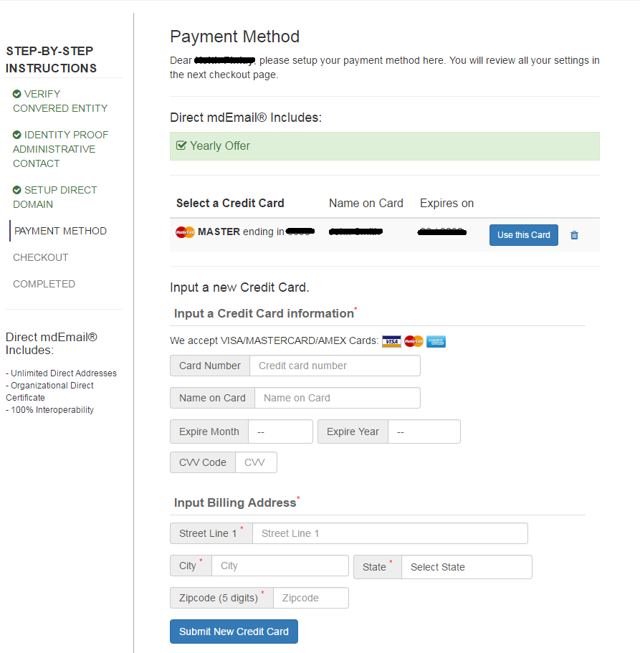

*Payment will be completed here and the left side shows what is included in the flat annual rate.*

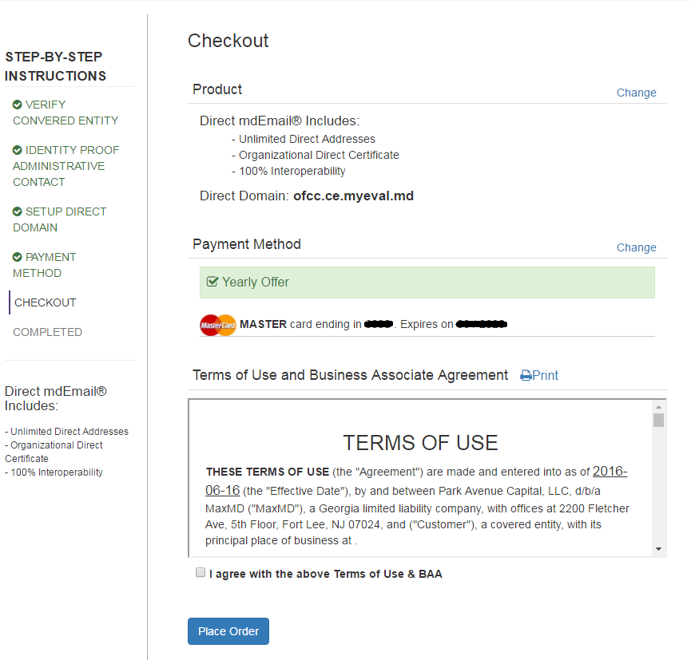

*A customer can print their Terms of Use and BAA from this checkout page.*

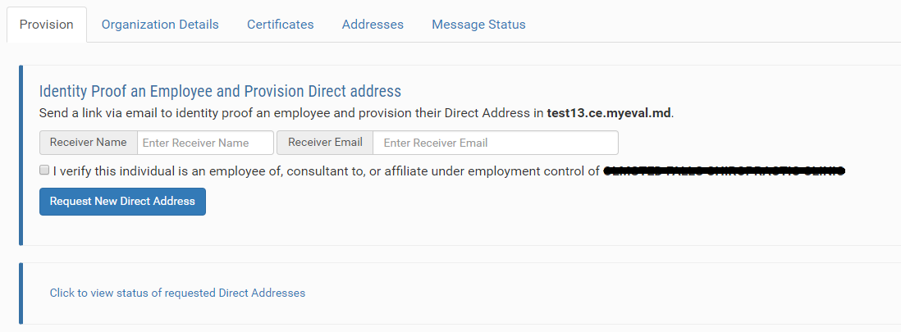

*Once the administrator checks out, they will log into their Direct Admin and have the ability to request Direct Addresses for their desired Users. Completing this form will initiate an email to a prospective User and prompt them to go through the required NIST LoA 3 identity proofing as the administrator did previously.*

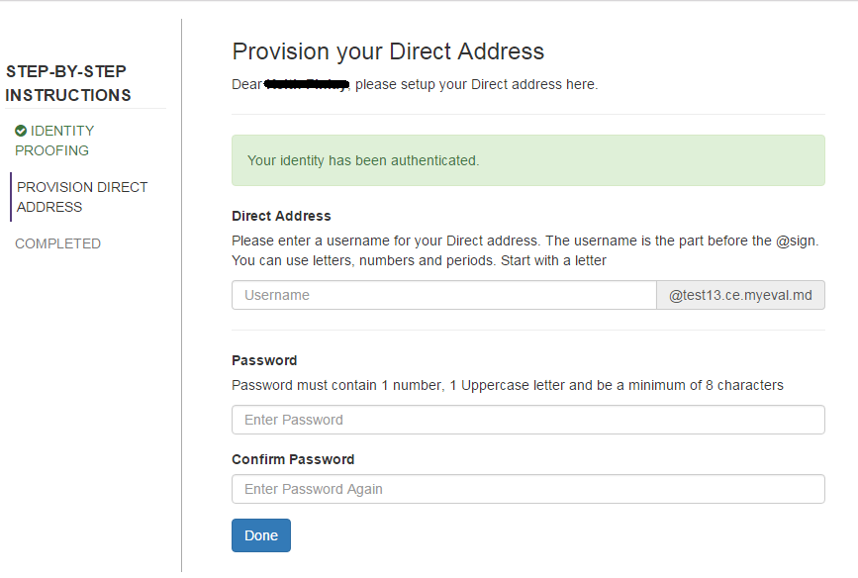

*Upon meeting the identity proofing standards a User can choose the Username for their Direct Address and set their password. Once set, they can log into their Direct Address on the web, in a portal, or sync with mail clients like Microsoft Outlook and add it to mobile devices.*